**Elastic Modulus of PT Bands**

**Summary:**Physical therapy bands are used for resistance when recovering from injury or when training. Different strengths of bands are used based on the exercise, strength of the person using them, and purpose for the use of the band. We will explore how to characterize materials and compare their physical properties.

ILOs: 1. Understand tensile testing and be able to calculate the Elastic/Young’s Modulus

2. Understand how to engineer/design an object to meet specific properties. You can change material, but you can also change the thickness, width, shape, etc to meet the properties that you need.

**Equipment list:**

* Dumbbell cut outs from each of a set of different resistance rubber PT bands. For example: <https://www.amazon.com/Resistance-Bands-Women-Men-Exercise/dp/B09HGVJ8GW/ref=asc_df_B09HGVJ8GW/?tag=hyprod-20&linkCode=df0&hvadid=693383516548&hvpos=&hvnetw=g&hvrand=16137487907835307458&hvpone=&hvptwo=&hvqmt=&hvdev=c&hvdvcmdl=&hvlocint=&hvlocphy=9002000&hvtargid=pla-1460363204121&mcid=32d98420736b350fb060cef2dff254f4&th=1>
* Force gauge
* Clamp attachment to force gauge
* Ruler
* Caliper (or provide thicknesses for each band)

**Intro:**

During the physical therapy exercises, you used a set of PT bands for different activities. For each activity, you selected the band with the appropriate resistance for you for the specific activity. We will now be quantifying the resistance of the bands by measuring the linear deformation regime for each material and then computing the elastic, or Young’s modulus for the bands. When calculating the young’s modulus, the force required to stretch the material a certain distance is normalized by the cross sectional area of the material.

Do you think all the bands will have the same modulus, indicating that they are the same material? What other ways can we manipulate material properties?

**Procedure:**

1. Measure the dimensions of each band. The dumbbell’s should be the same size, the thickness will vary for each band. You can use the total length of the band as L0. The width for calculating the cross sectional area is the width at the thin center area of the dumbbell.

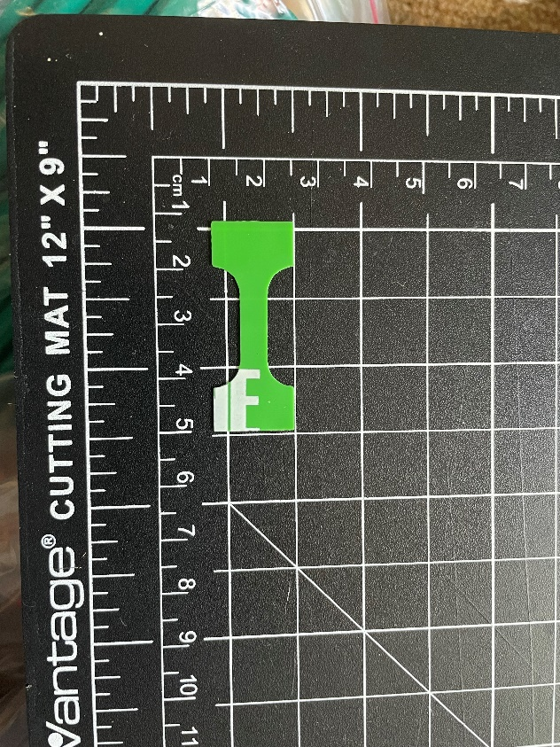

1. Attach the clamp to the force gauge and zero it. Pull the end of the band a few millimeters, and record the force required as well as the distance pulled. The distance the end was pulled is L-L0. The force will be normalized by the cross sectional area to get the stress.

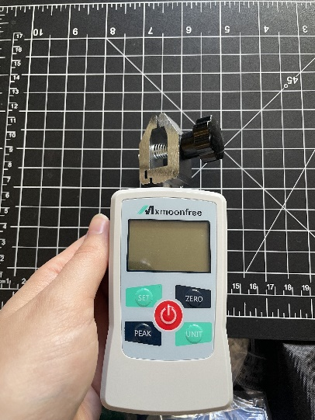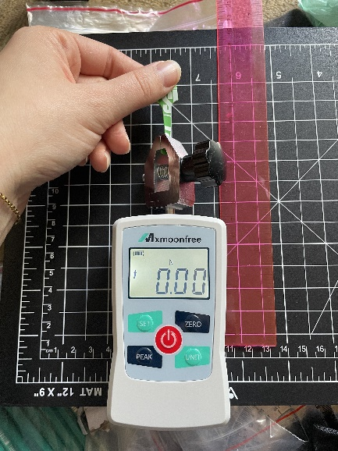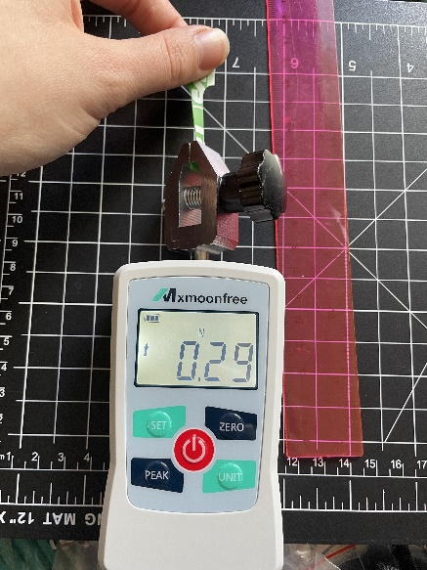

1. Repeat step to at 3-5 different lengths.
2. Calculate the stress for each datapoint. $Engineering Stress σ=\frac{F}{A_{0}}$
3. Calculate the strain for each datapoint. $Engineering Strain ε = \frac{L-L_{0}}{L_{0}}$
4. Plot these values and find the slope of the resulting line. If the data becomes non-linear at high strain values, use only the slope of the linear section. The slope of the linear portion of the stress vs strain curve is the young’s modulus.

**Analysis:**

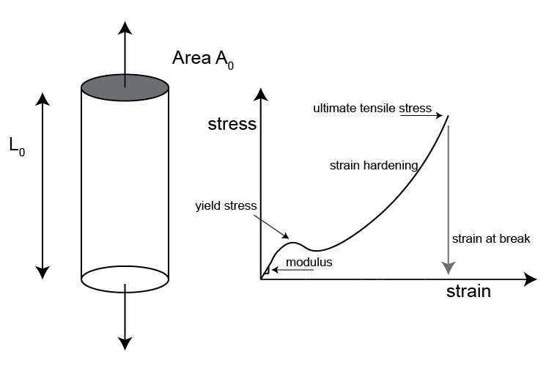

**Discussion questions/debrief:**

What modulus did you calculate for each band? Were they different or the same?

Are the bands made of different materials or the same material?

How can we tune the properties of an object (like a physical therapy band!) using information about physics and the material? Why is this important?

**Lab handout needed?**

Yes